**Moulik Tammana**

**Q3.** **Given a network address of 10.0.0.0/24, divide it into 4 equal subnets. Calculate the new subnet mask. Determine the valid host range for each subnet. Assign IP addresses to devices in Packet Tracer and verify connectivity.**

|  |  |  |  |  |  |
| --- | --- | --- | --- | --- | --- |
| **Subnet Number #** | **Network Address** | **Starting usable IP address** | **Last usable IP address** | **Broadcast address** | **Total number of hosts capacity** |
| **1** | **10.0.0.0/26** | **10.0.0.1** | **10.0.0.62** | **10.0.0.63** | **62** |
| **2** | **10.0.0.64/26** | **10.0.0.65** | **10.0.0.126** | **10.0.0.127** | **62** |
| **3** | **10.0.0.128/26** | **10.0.0.129** | **10.0.0.190** | **10.0.0.191** | **62** |
| **4** | **10.0.0.192/26** | **10.0.0.193** | **10.0.0.254** | **10.0.0.255** | **62** |
| **Total** | **-** | **-** | **-** | **-** | **248** |

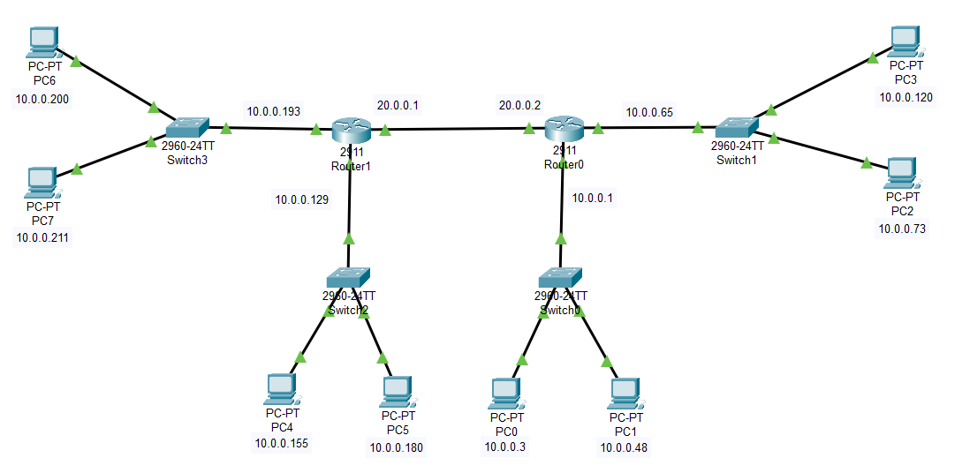

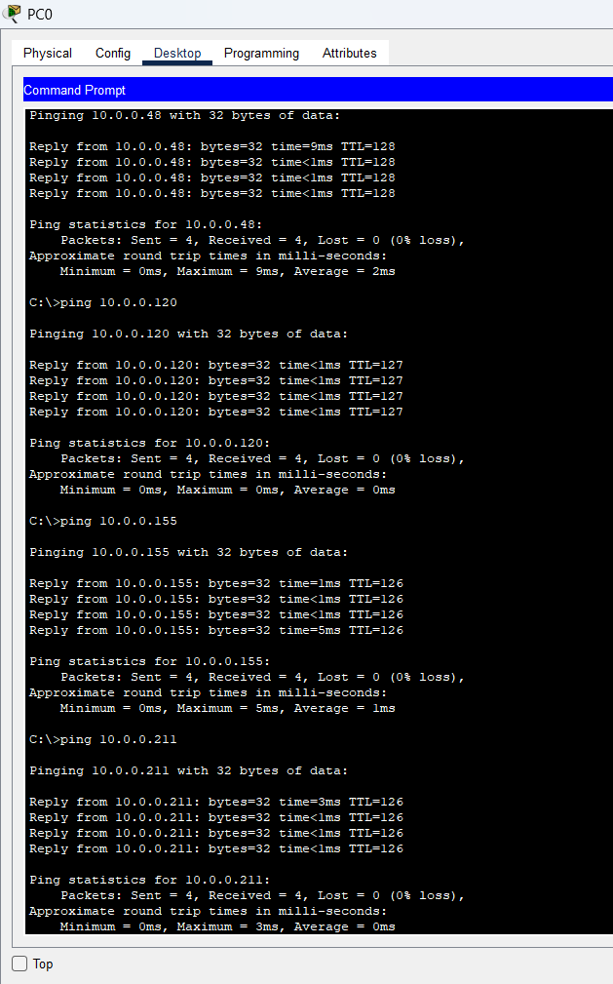

**We are able to ping every end device in different subnets from PC0. This shows that the connectivity better all the PC’s is working properly and the below image shows the static ip routing between the networks in router0 and router1 respectively.**

